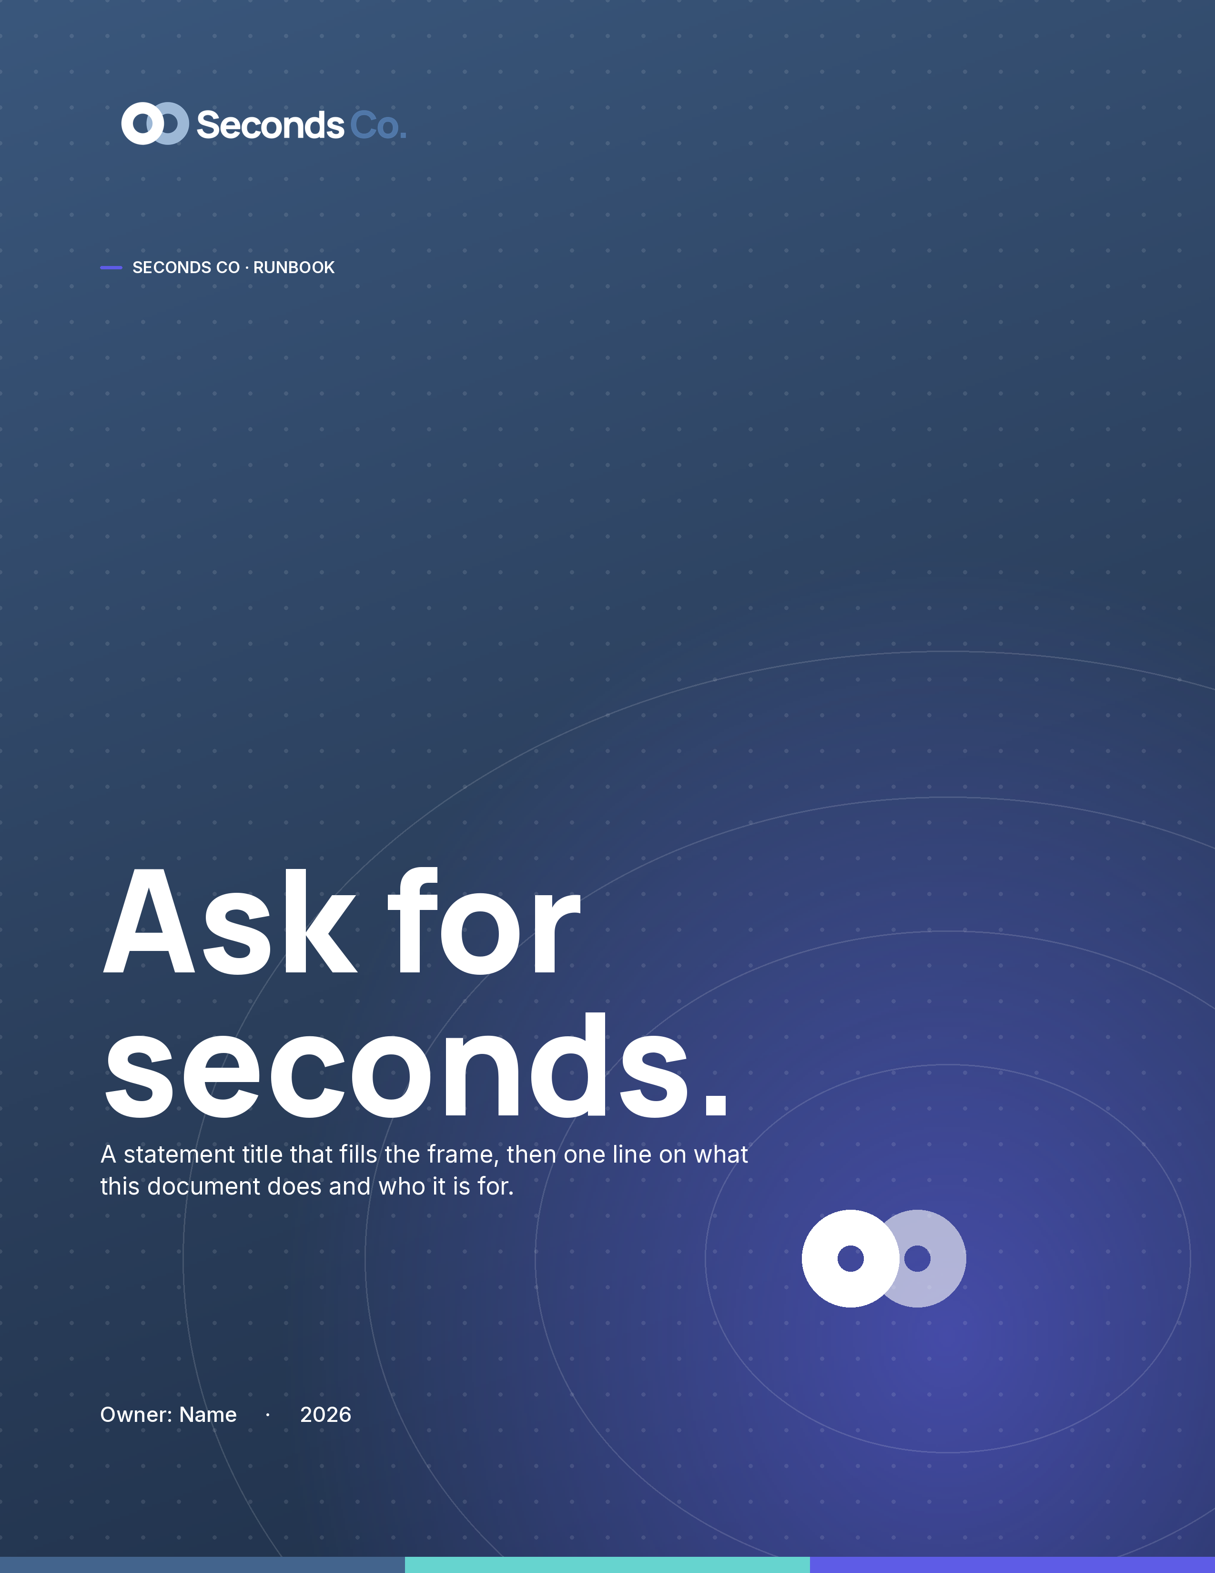

— SECTION 01
How we open.
This is the lede. One or two lines that set up the section, in Inter at a comfortable measure, before the body begins.
The morning, start to finish
This is the body style: Inter, ink, comfortable line height. Short sentences, one idea per paragraph. It should read like a person talking, not a policy talking.
Every new heading, table, and list you add inherits Inter and Inter with Blue Aura colour, because the brand lives in the theme, not in one-off formatting.
“Two things make a pizza.”
Say the plain thing, then stop.
The steps
 Say what happened. One line, plainly. No preamble.
 Say what happens next. Name the owner and the date.
 Come back for seconds. If it worked, do it again.

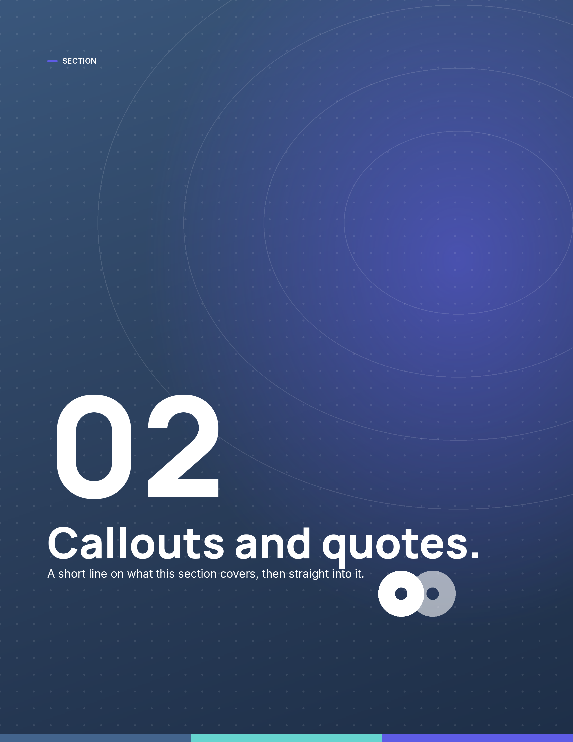

— SECTION 02
Callouts and quotes.
Tables inherit the theme too: a magenta header row, hairline rules, tint banding.
Step | Owner | When
Open the day | Jason | 8:00
Clear the noise | Axis | 8:15
Come back for seconds | Team | EOD

